

IB16S
Introductory Bioinformatics
12-16 December 2016

(Second 2016 run of this Course)

Basic Bioinformatics Sessions

Practical 4: Primer Design

Monday 5 December 2016
Primer Design
To determine the presence or absence of the mutation we have detected, a test based on restriction maps could be employed. This approach is investigated in one of the supplementary exercises at the end of this book. In that extra exercise, it is shown there is more than one restriction enzyme whose cut site is dependant upon the mutation. With a little more work (with the same programs), we could easily ascertain exact restriction fragment sizes expected for selected enzyme(s) with the mutation and without it. As long as the differences were sufficiently unsubtle, a Restriction Fragment Length Polymorphism (RFLP) test could be designed.
For a variety of reasons, including the ready availability and ever decreasing cost of sequencing, this is typically not the preferred way to proceed. It is normally preferable to use PCR to isolate the region around the mutation and sequence all individuals under examination. To do this, the first step would be to design suitable PCR primers. One program, in many different forms, is almost exclusively used for this purpose. The program is primer3. It is free and can be downloaded and run under linux and windows (at least). It is available as part of the EMBOSS package (eprimer3) and from a number of websites, including at the Massachusetts Institute of Technology (MIT):
http://frodo.wi.mit.edu/
This site is popular with many users offering complete control over the various options offered by primer3.
Another excellent primer3 web interface developed in the Netherlands is available at:
http://www.bioinformatics.nl/cgi-bin/primer3plus/primer3plus.cgi
The site incorporates access to a blast search to check the uniqueness of the selected primers (important if unwanted PCR products are to be avoided).
Mostly because of its completely seamless inclusion of a blast search to compare potential primers with appropriate sequence collections, I suggest we here use primer3 as implemented at the NCBI, even though it offers less than complete control over the execution of primer3 itself. Go to:
http://www.ncbi.nlm.nih.gov
Click on the BLAST option. Select Primer-BLAST from the Specialized BLAST section.

Upload your genomic PAX6 sequence using the Browse (or Choose File) button for the PCR Template.

You have established that the mutation of greatest interest is the G/C substitution at position 15714 of the genomic sequence copied from Ensembl. It is logical therefore to specify that this feature be included in the PCR product not too near either end. Accordingly, request the Forward primer to be chosen From the region starting at base pair 15000 and continuing To base pair 15700. Set the range for the Reverse primer to be From 15800 and To 16500.
The default PCR product size is specified in the Primer Parameters section as between 70 and 1000 base pairs. This seems fine.
I would not presume to advise you on the melting temperatures that were most suitable. For this exercise, the defaults work splendidly.
By default, primer-BLAST will report the best 10 primer pairs it can find (# of primers to return). This is plenty for the exercise.
Do you think 10 primer pair suggestions is sufficient? If not, what number would you choose?

In addition to running primer3 to suggest primers, Primer-BLAST checks against the possibility of unwanted PCR products by comparing potential primers against an appropriate sequence database with blast.

In the Primer Pair Specificity Checking Parameters section, set the Database selection to RefSeq representative genomes. Leave the Organism set as Homo sapiens.
You thus request each potential pair of PCR primers to be compared to the entire human genome. Thus unintended products of similar size to the intended product, can be identified.
The ideal conclusion is “just one product will be produced, on chromosome 11, in the region of the PAX6 gene”.
Use the appropriate button to discover the purpose of the Max target size parameter.
This is a new parameter replacing a very different parameter, the purpose of which was somewhat less obvious. The reason for the Max target size parameter is surely pretty transparent, so maybe there is now less requirement to wake up itsbutton? For the present, the maximum size of any proposed PCR product, in this instance, is 1,000 base pairs (the form default). So the greatest size of an unwanted product that might be a problem (the Max target size) must be small enough to potentially be mistaken for a real product of 1,000 base pairs. 4,000 base pairs seems a bit cautious to me? However, unless you feel strongly about the matter, accept the default value of 4000.
What value would you choose here if you were looking for uncluttered results?

Before setting primer-BLAST going, click on the Advanced parameters button. Not really so Advanced? More Avoidable by those in a hurry. At the top are the Primer Pair Specificity Checking Parameters that control the way that blast is run. Note thebuttons offering explanation.
Note the very high default Blast expect (E) value, suggesting you will be interested in matches with your primers that might occur up too 30000 times by chance! This does make sense as the primers will be very short and so many good, even exact, “chance” matches might be expected against a large database.
Comment upon the small default value for the Blast word size?



Note that you could get primer-BLAST to suggest an Internal hybridisation oligo, but decline the invitation this time.

Accept all the Advanced parameters as they are. Ask primer-BLAST to Show results in a new window.
Click on the Get Primers button.

After a few moments of deep thought, primer-BLAST will notice that the template sequence you are using is highly similar (identical in fact) to part of an entry in the database being searched. Hardly surprising if one was to think about it.
You are invited to select all listed regions (just one this time) where matches with primers are likely to be the intended product. In this case, that is the whole list of one, so click on the All button.
Every pair of primers that primer3 selects must match this region of Chromosome 11 as it is precisely the region investigated by primer3 in the first place. This process avoids blast reporting intended products as unintended products. Finally, all is ready, so ask to Show results in a new window and then click on the Submit button.
Once you have revelled in the opportunity to twiddle the fingers and scratch the ear(s) whilst primers3 and blast go merrily about their appointed tasks, you will receive your results. These should look disarmingly like mine if all has gone well, in Summary and in Detail.
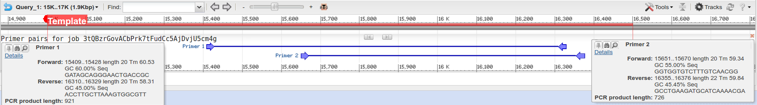
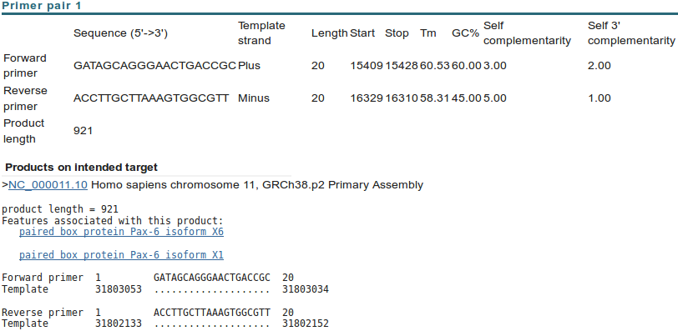
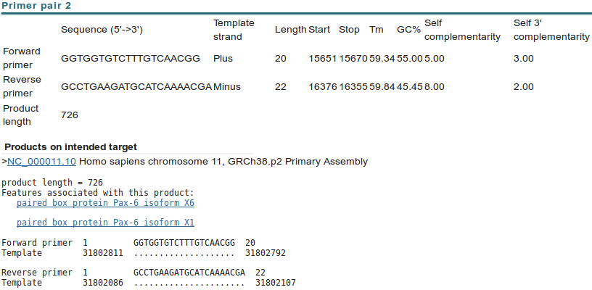

Just two solutions met the default criteria for success used by primer3. Up to 10 were permitted. Hovering over the graphical results will bring forth textual summaries. Try it. Note the rather ugly job identification! Clearly, the poetry generated for your results is extremely unlikely to be the same as illustrated.
Neither of your two suggested primer pairs should be associated with any unintended products, even with the very generous suggestion that products 4000 bases long should be considered a potential problem.
As well as suggesting primers for PCR (or other purposes) and (optionally) suggesting hybridisation oligos, primer-BLAST can be used to evaluate user-selected primers. Earlier, you saved a pair of primer sequences associated with PAX6 when searching the nucleotide databases at the NCBI. It would be interesting to discover the product these might produce. To do this you need an unsullied Primer-BLAST page. Go again to:
http://www.ncbi.nlm.nih.gov
Click on the BLAST option. Select Primer-BLAST from the Specialized BLAST section. Upload your genomic PAX6 genomic sequence using the Browse (or Choose File) button for the PCR Template.

Open up the file you made containing the primers from GenBank (pax6_primers.fasta) in a text editor.
Copy and Paste the two primer sequences into the Use my own forward primer and Use my own reverse primer boxes as appropriate.

In the Primer Pair Specificity Checking Parameters section, set the Database selection to RefSeq representative genomes.
Leave the Organism as Homo sapiens.
Raise the Max target size parameter from 4000 to 20000. You should check for enormous unintended products with this run of Primer-BLAST. The reasons for this will soon become apparent.
Ask primer-BLAST to Show results in a new window. Click on the Get Primers button.
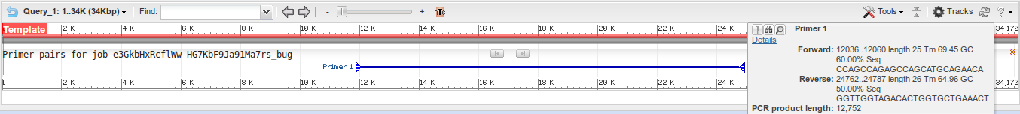
After a short thrill filled pause, you will receive a result that should again looks more that a trifle like mine.
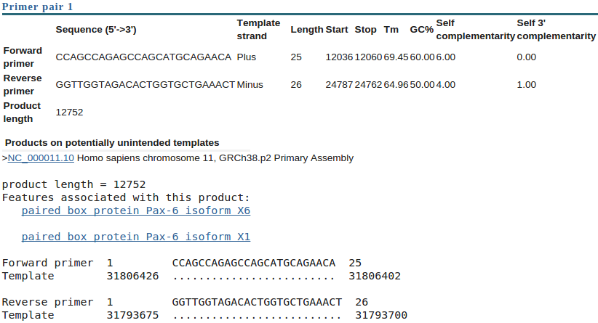
Seemingly a fine match. Even the single potentially unintended product reported is actually the intended product. For some reason, Primer-BLAST does not distinguish between intended products and unintended ones when investigating user specified primers?
Success! However, applying a small measure of sober reflection, one has to wonder at a PCR product of 12,752 base pairs? I suspect that to be just a tad on the boastful side of probable? Clearly, primer-BLAST is convinced, but maybe a look at the references that came with these primer sequences would be advised before accepting this result at face value.
Unfortunately, the only paper referenced does not explain what might be going on particularly clearly. However, there is a hint that the primers you saved were designed for use with mRNA/cDNA data. Therefore it might be interesting to run primer-BLAST one last time with pax6_cdna.fasta as the PCR Template.

Simply move back to your last primer-BLAST launch page. This time, load pax6_cdna.fasta as the PCR Template.
In the Primer Pair Specificity Checking Parameters section, set the Database selection set to Refseq mRNA and leave the organism set to Homo sapiens.
Set the Max target size back to its default value of 4000, you should expect much smaller mRNA products this time, so no need for extending this maximum beyond 4000.
These selections suppose that the design of PCR product was for selection from a library of all human cDNAs.
Ask primer-BLAST to Show results in a new window. Click on the Get Primers button.

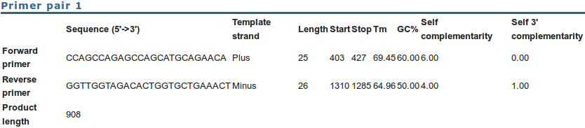
The result is a much more reasonable Product length of just 908 base pairs,reinforcing the theory that these primers were indeed designed for use with a cDNA library.
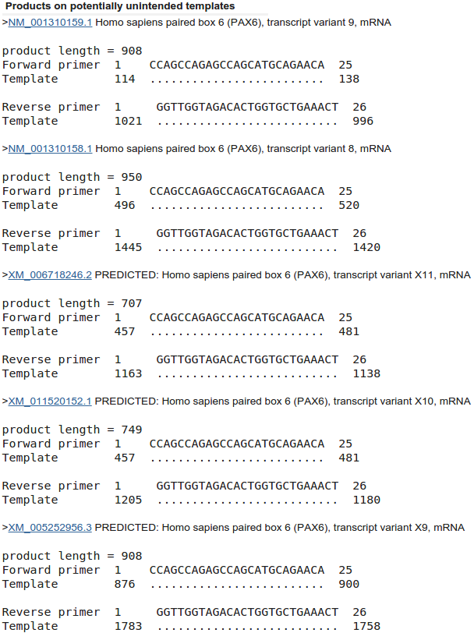
Before moving on, afford a quick glance at the report offered concerning possible unintended products. Here primer-BLAST warns against human mRNAs that might be cloned along with the intended target.
The first thing to note is that the intended target is not generated from a RefSeq mRNA. It comes from an mRNA taken from an aniridia patient directly. Therefore, there is no unintended product that we can ignore because it is really the intended product discovered by a different route, even though no filtering of the RefSeq database was undertaken.
All the unintended products could/would potentially be generated by the primers under investigation and have the potential to cause confusion. If you look down the list, you should conclude that the 16 unintended products come from 16 of the 24 RefSeq PAX6 transcripts first noted by GeneCards and then confirmed later by blast.
9 of the 11 NM_ good quality transcripts are detected. 7 of the 13 poorer quality XM_ “PREDICTED” transcripts are also present. So 16 of the 24 PAX6 transcript sequences in RefSeq were detected.
Why do you suppose blast did not pick up all the transcripts?

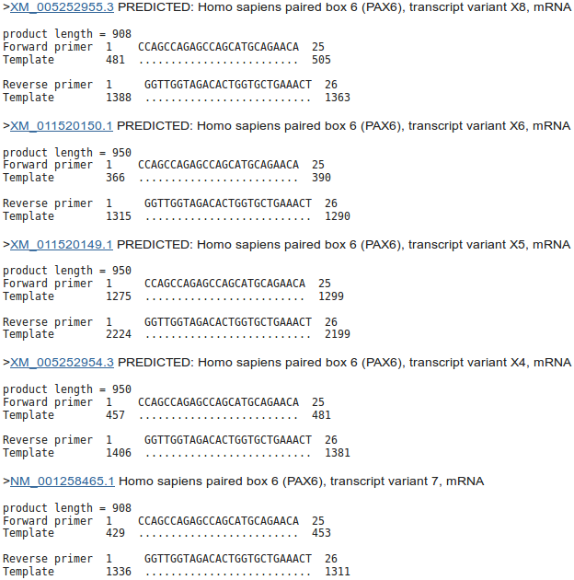
Note that the intended product is 908 base pairs long. Note that all the unintended products except two, near the top of the list are either 908 long or 950 long. A difference of 42.
How would you tell quickly which isoform was represented by each mRNA listed here?

Some fairly redundant questions to finish this section. I think I have already answered them all. But maybe you might wish to differ?
Is the number of “potentially unintended products” as you would you expect, given the evidence from GeneCards, Ensembl and blast?

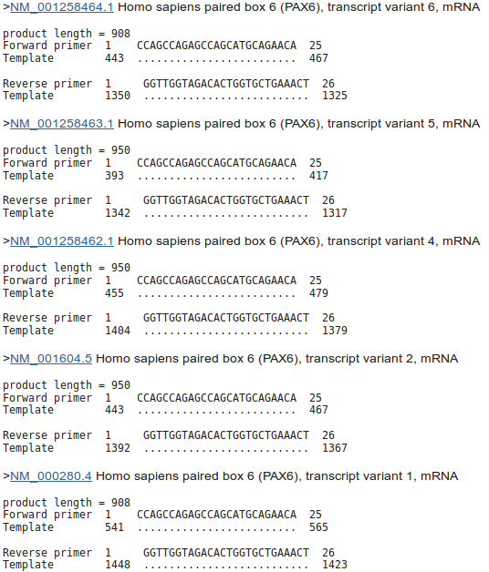

For all the “potentially unintended products”, the selected primers match exactly. Can you explain this?

The “potentially unintended products” are of different sizes. Can you explain the difference between the possible product lengths?

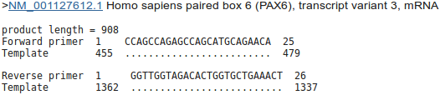
Are the numbers of “potentially unintended products” of each possible length consistent with your blast results?

DPJ – 2016.12.05
Model Answers to Questions in the Instructions Text.
Notes:
For the most part, these “Model Answers” just provide the reactions/solutions I hoped you would work out for yourselves. However, sometime I have tried to offer a bit more background and material for thought? Occasionally, I have rambled off into some rather self indulgent investigations that even I would not want to try and justify as pertinent to the objective of these exercises. I like to keep these meanders, as they help and entertain me, but I wish to warn you to only take regard of them if you are feeling particularly strong and have time to burn. Certainly not a good idea to indulge here during a time constrained course event!
Where things have got extreme, I am going to make two versions of the answer. One starting:
Summary:
Which has the answer with only a reasonably digestible volume of deep thought. Read this one.
The other will start:
Full Answer:
Beware of entering here! I do not hold back. Nothing complicated, but it will be long and full of pedantry.
This makes the Model answers section very big. BUT, it is not intended for printing or for reading serially, so I submit, being long and wordy does not matter. Feel free to disagree.
From your investigations of Primer Design
Do you think 10 primer pair suggestions is sufficient? If not, what number would you choose?
Until very recently, the default here was 5. That seemed rather low to me. I included this question to solicit opinion rather than to impart knowledge. A default of 10 seems more in line with my instincts, but people who use this program seriously mostly tell me that they can select suitable primers from the first 2 or 3 suggestions of the program. So, 5 would seem a good choice and 10 would be moving towards cautiously overdoing things.
On the whole, informed opinion suggests that 10 suggestions will be more than enough in most circumstances.
What value would you choose here if you were looking for uncluttered results?
Summary:
Clearly, the smaller the number chosen, the shorter will be the list of spurious products. However, pick something too small and you risk including unintended product(s) that could cause confusion. The size selected must be sufficient that larger unwanted PCR product(s) could easily be spotted by other means (simply by size?).
Full Answer:
Well, mostly for me, and just in case you were curious, when I first wrote the question, the parameter was very different and not so easy to understand. Pure self indulgence, I know, but here is the history. The parameter explained itself, via thebutton, thus:
I interpreted this to mean that only blast predicted products of up to X+4,000 base pairs, where X base pairs is the length of the intended target, will be given any regard. It is thus assumed that a difference of 4,000 base pairs between an intended PCR product (predicted by primer3) and a spurious product (detected by blast) can easily be detected simply by size difference.
Of course this parameter also will reject unwanted blast predicted products that are less than X–4,000 base pairs will be given any regard. Given the largest possible primer3 suggestion will be 1,000 base pairs (the form setting for the exercise specifies products of between 100 and 1,000 base pairs), this is hardly an issue here.
Comment upon the small default value for the Blast word size?
By default, blast will be looking for aligned exactly matching blocks of 7 nucleotides when identifying where a primer might match a database entry. The entire primer match with the template sequence does not have to be exact for the primer to be acceptable. The entire primer is typically only around 20 bases long. And word size much more that 7 would clearly miss too much to be effective.

Why do you suppose blast did not pick up all the transcripts?
Summary:
Well, the simple answer is that the transcripts that were not detected as unwanted products cannot include either the forward primer, or the reverse primer, or both. This is, almost, the only possible explanation.
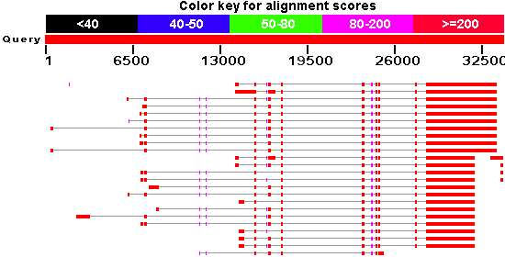
Full Answer:
Of course, for this run, you did specify that you were not interested in products longer than 4,000 base pairs, so it could be that one or more products were possible but longer than that? I suspect this would only be feasible if there were retained introns involved, but previous blast results do not suggest this to be the case. I would say the only possible candidate for an over-length product might be the second hit down in the graphical representation generated previously by blast. The first and third exons from the left look a bit bloated, but not really sufficiently to cause a problem.

It might also be that unwanted PCR products are eliminated/introduced due to variations in the predicted transcripts. However, this can be ruled out as previous experiments, blast assures us that all 24 potential transcripts match the genomic sequence exactly.
Enough! Only because I want to, I will compute the alignments to prove the missing primer matches. Read no further unless you are truly in the mood. Much of the reason for recording the rest of this answer is that, apart from enjoying the pursuit of irrelevant detail, I also wanted to remember how I made the alignments and certainly feel I could have made both these, and my point much more simply? Suggestions welcome.
OK, I started by computing an alignment that was a mapping of all 24 transcripts onto the PAX6 genomic regions as represented in the file pax6_genomic.fasta. I used a program called gmap, which like spline (used in the exercise) is designed to align cDNA/mRNA sequences with corresponding genomic sequences. The version of gmap I used runs under linux from the command line. It has the advantage over spline that is will align more than one cDNA/mRNA sequence against the genome in one run. Unfortunately, it does not generate an output format that can be easily displayed in the way I required here. I did try to persuade a couple of general multiple alignment programs (clustalw & muscle) to make me a usable alignment, but ran into the same difficulties we experienced in the exercise. I failed to find gap penalties that would get the programs to gap the larger introns. Even if I had succeeded to get the gaps in the right place, I would not have believed them to be placed with sufficient accuracy for the same reasons this was not possible when we tried the same trick with general alignment software for just one cDNA sequence against the genome in the exercise.
So, I made a rough alignment with clustalw and edited it to exactly what was suggested by gmap using jalview. This took HOURS. There has to be a better way!! You have already used all the software mentioned except gmap and clustalw. You will use clustalw and see how jalview can be use to edit, as well as just view, alignments a little later.
All that effort to show that the region around the forward primer looks like this:
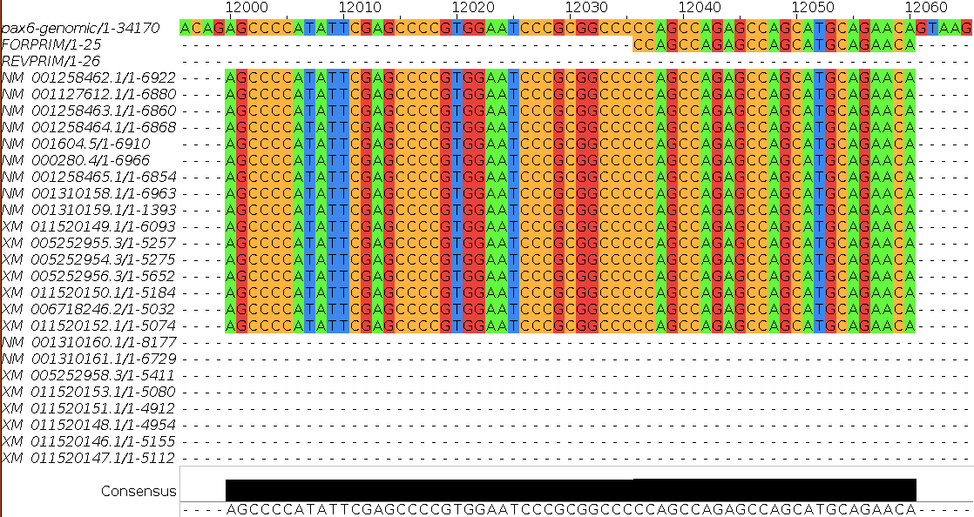
Showing clearly that the 8 transcripts:
NM_001310160.1
NM_001310161.1
XM_005252958.3
XM_011520153.1
XM_011520151.1
XM_011520148.1
XM_011520146.1
XM_011520147.1
Have the exon that includes the forward primer spliced out and so will not produce any PCR product. Feel free to check this by comparing the textual results of your blast of the genomic sequence against the RefSeq mRNAs and the results of PRIMER-BLAST. I did, it was lots and lots of fun and I ended up content that all was logically consistent.
The alignment around the reverse primer looks like this:
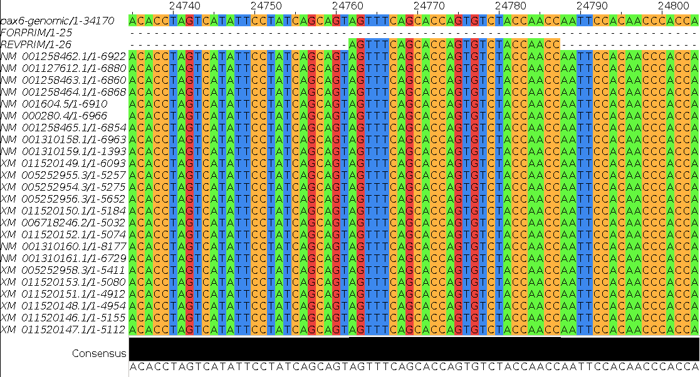
All 24 putative transcripts match the reverse primer perfectly. So blast should indeed find 16 of the 24 transcripts sequences in RefSeq, and it does.
Jalview offers an overview of the entire alignment. The top row shows the genomic sequence. The second row shows the position of the forward primer. The third row shows the position of the reverse primer.

Except for the order of the transcripts, this view is very similar to the overview graphic generated by blast. The transcripts missing the forward primer, which isoform each transcripts represents and the fact that all transcripts match the reverse primer should be very clear.
Finished Dave? Well no, not quite. I wondered why I had included the genomic sequence in my alignment. Finding no answer to that question, I tried to make an alignment of just the primer sequences and the mRNAs. I thought this would be easy. I was wrong. The general programs are still going to get the gaps wrong whatever penalties are used. Some transcripts have exons entirely missing in all other transcripts leaving no clues as to which way round they should be aligned. The scaffold provided by the genomic sequence was essential. So, I made an mRNA only alignment by editing the alignment discussed above with jalview. This was easy (although you would not think so given the time it took me to work out how to do it!). I loaded the alignment into jalview, deleted the genomic sequence and then removed all empty columns (that is, all columns with no bases in them due the the removal of the genomic sequence). Clever eh? Just because it is there, here are the pictures.
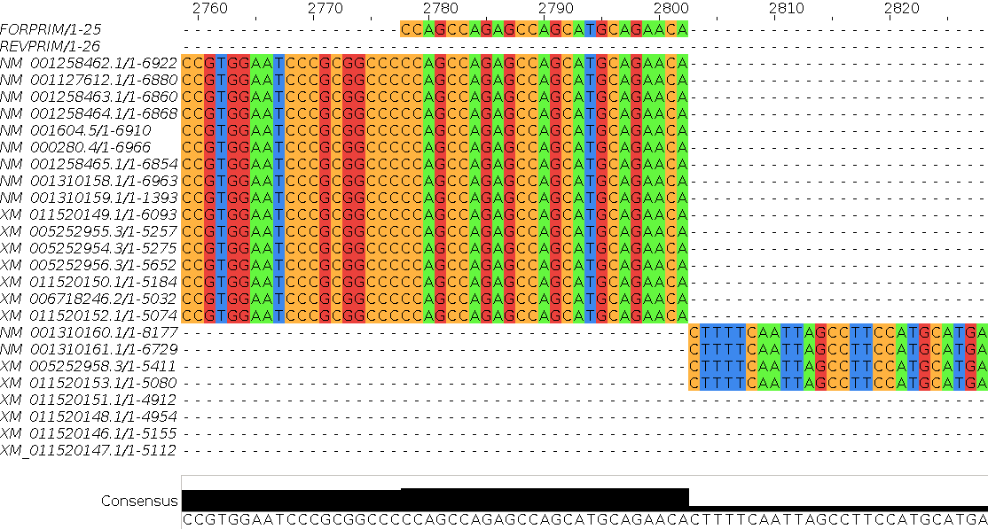
Forward primer region (the primer is right at the end of an exon):
Reverse primer region:
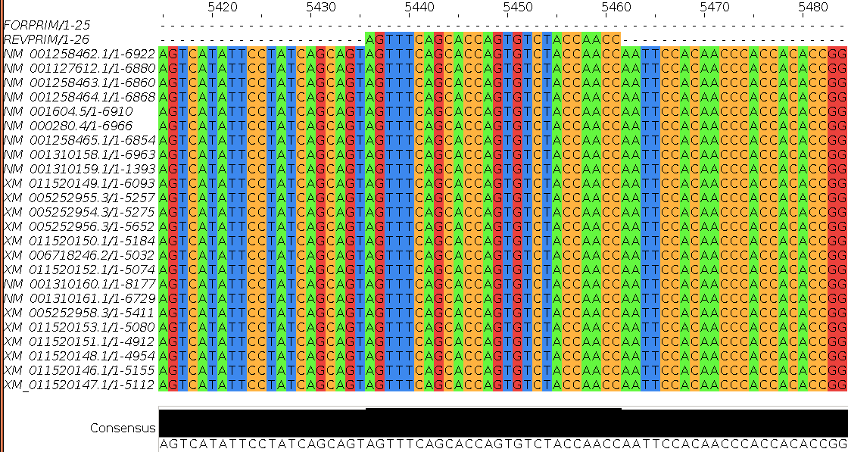
Overview:
Without the evidence of the genomic sequence, the two leftmost exons could logically swap position. There is no transcript that includes both these exons and no overlap between either and any other exon in any transcript (most clearly verified from the previous Overview plot). Thus, there is no exon evidence of the order in which the two should appear.

Now I am done! This has to be the most over the top answer yet, but at least it kept me out of trouble for a while.
How would you tell quickly which isoform was represented by each mRNA listed here?
Summary:
All the mRNAs reported were of length 908, 950, 707 or 749.
A reasonable guess might be based on the length of the products? All those that are 908 bases might be assume to produce the 422 amino acid canonical isoform. All those that are 950 (i.e. 42 base pairs longer) might be assumed to 436 produce amino acid isoform 5a proteins (i.e. 14 amino acids longer).
Analogous reasoning might be applied to the mRNAs that are either 707 or 749 base pairs in length.
Just a guess of course, but one I would be happy to have faith in. To be certain, one would need to read the annotations of each listed RefSeq entry!
Full Answer:
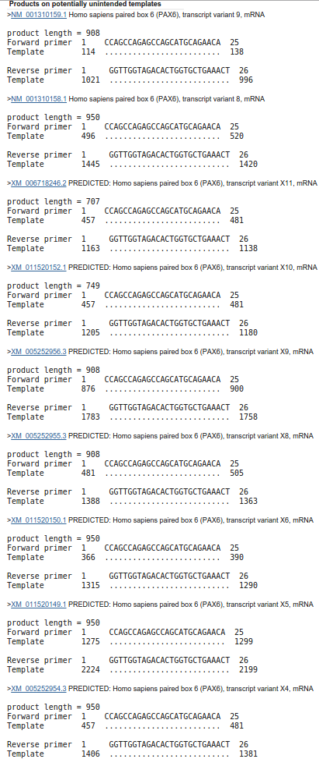
From the illustrations of the last “Full Answer” (in particular, the jalview overviews), it is clear that all the mRNAs that produce a product include the region that determines which isoform is represented. That is, all are one isoform or the other.
The last two of the mRNAs that produce a PCR product, have a bit chewed out just after the isoform defining region (an exon spliced out, if you prefer). It is logical to suppose these would be the mRNAs from which the two shorter products were generated.
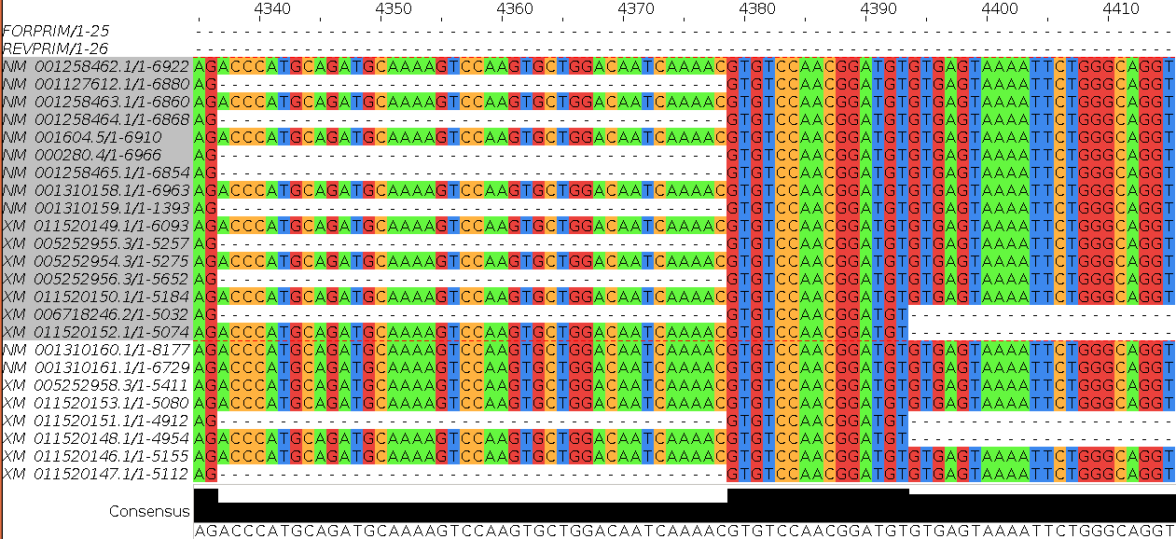
Indeed, looking at the relevant part of the mRNA only alignment shows them to be XM_006718246 (product length 707, excluding the isoform 5a exon that suggest it codes for a canonical protein) and XM_011520152 (product length 749, including the extra 42 base pairs suggesting it codes for an isoform 5a protein ).
All other transcripts that generate PCR products generate products of length either 908 or 950. Given the difference (42 base pairs) is exactly the size of the isoform 5a exon, it is reasonable to assume the transcripts generating PCR products of length 908 represent canonical proteins, whereas the transcripts generating PCR products of length 950 represent isoform 5a proteins.
Prettier? True, and I submit including sufficient evidence to be more that just a guess now.
Is the number of “potentially unintended products” as you would you expect, given the evidence from GeneCards, Ensembl and blast?
Yes, I think so, given you accept my investigation (see above) as to why there were only 16 “potentially unintended products” when you might have expected 24, given your blast results. GeneCards now encourages an initial expectation of 24 “potentially unintended products”. Ensembl only uses the higher quality RefSeq mRNAs. Currently, Ensembl uses 10 of the 11 good quality RefSeq mRNAs to make its transcripts predictions. Close enough?
For all the “potentially unintended products”, the selected primers match exactly. Can you explain this?
Well, of course they do??? All the transcripts found are generated from the same region of genomic DNA and therefore will be identical in all shared regions, including the primer regions. I suppose, in other instances, it would be possible to have transcripts with variation in the regions matching the primers insufficient to stop the primers working? But not in this case.
One might conclude there are no genuinely “unintended” products? All are real PAX6 transcripts of varying certainty. A genuine unintended product would come from an entirely different part of the genome and would not necessarily match exactly with respect to the primers. They would just need to be “good enough to work”.
The “potentially unintended products” are of different sizes. Can you explain the difference between the possible product lengths?
Are the numbers of “potentially unintended products” of each possible length consistent with your blast results?
Yes yes yes! I think both these questions made a bit more sense a few generations of these notes ago. We have already answered them sufficiently I suggest. I refer you to the answers above.

DPJ – 2016.12.05

The MIT now link to a newer version of primer3 (version 4.0.0, soon primer4 maybe?). Its URL is: http://bioinfo.ut.ee/primer3/. I have yet to investigate this version fully.
My policy has been to not discuss parameters that pertain to the experimental conditions. In future versions of these notes, I will include discussion of some of these parameters. In the mean time, thebuttons are very helpful. I would also suggest the MIT site (or the Wageningen site) for very readable explanations linked from every parameter. The full primer3 manual can be found here.
Which rather makes mock of all the deep thought employed deciding upon the most sensible maximum number of predictions to be reported.
This was not true until very recently. Primer-BLAST reported many more primer pair suggestions and quite a few unintended products for each. The previous parameter restriction the length of unintended products was somewhat more generous.
I have asked the guys at NCBI to explain. No full answer as yet, further prodding required. Prodded last 2016.04.02.
Apparently, such a PCR product is possible! However, above 5,000 base pairs would be slow, require very close attention and be prone to errors.
The form explicitly declares a minimum of 70, but the ranges from which the forward & reverse primers must come (15000-15700 & 15800-16500) make the smallest possible primer3 prediction 100 base pairs long.

